ASSIGNMENT 2:

* Create an Amazon EC2 instance using a custom AMI.
* Attach a new volume to the instance and format it.
* Mount the volume and store a sample text file in it.
* Write a document detailing the creation and attachment process.

Step-1 created a custom AMI for ec2 instance

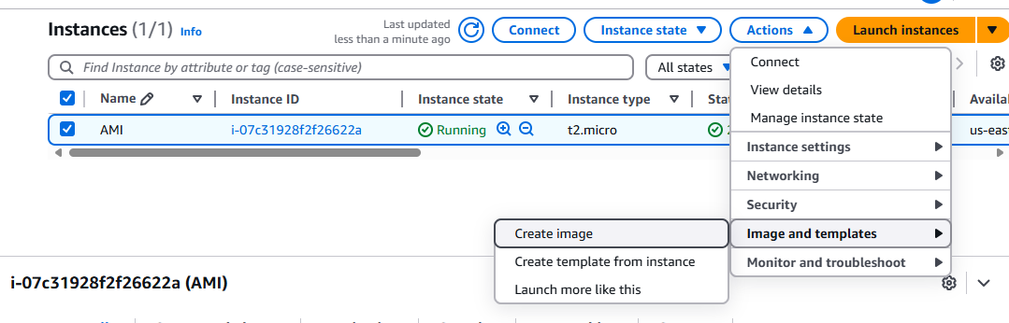

Step-2 AMI to create MY Image

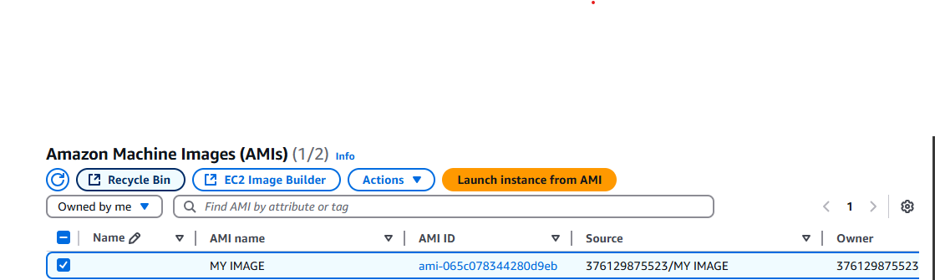

Step-3 this is custom AMI _details

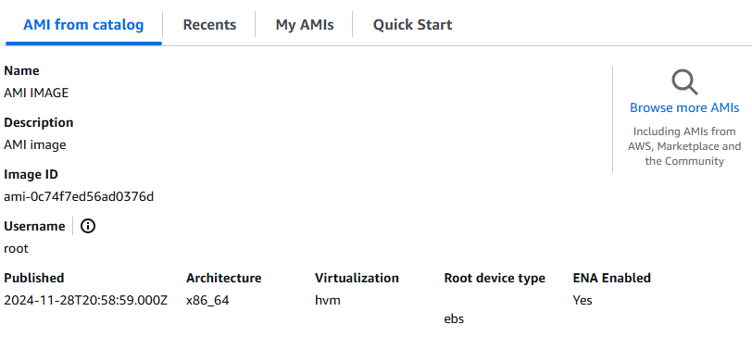

Step-4 launching ec2 instance IN MY IMAGE (AMI)

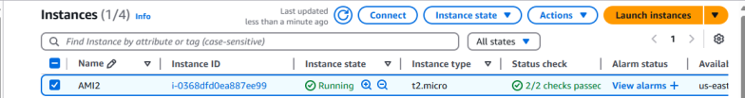

STEP-5 copy the ip and paste the new web server they we get output without any software installation and configuration

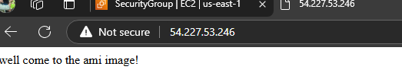

STEP-6 Now attaching new volume in ec2 instance first creating volume

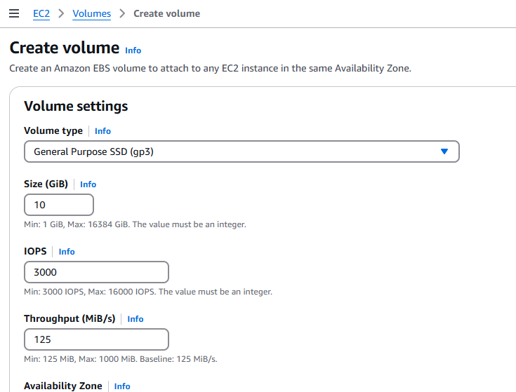

Volume was created

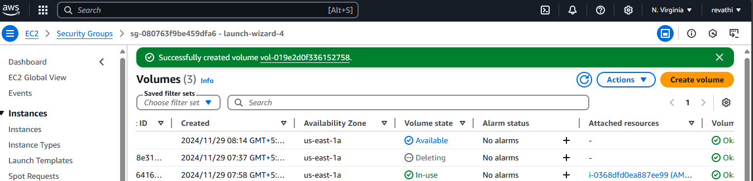

But the volume is only available state

STEP-7 Attach the volume in instance

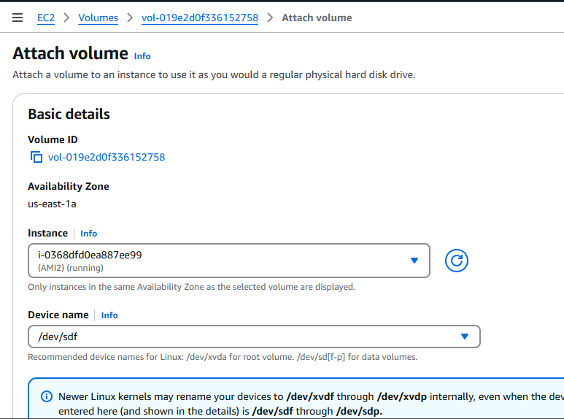

After attach volume state is in-use

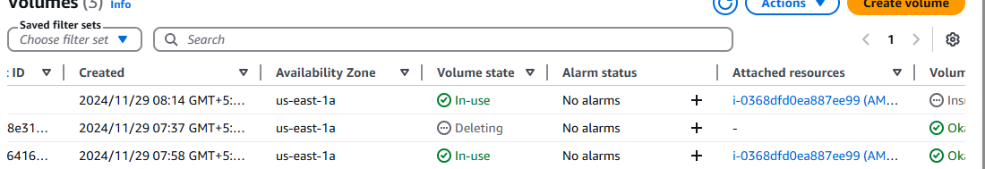

Mounting the volume and store a sample text file

List of devices 🡪lsblk

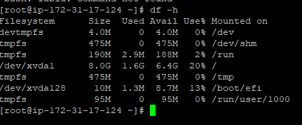

Check file system🡪file –s /dev/xvdf

Create a file system 🡪mkfs –t ext4 /dev/xvdf

Create directory 🡪mkdir /tmp/disk2

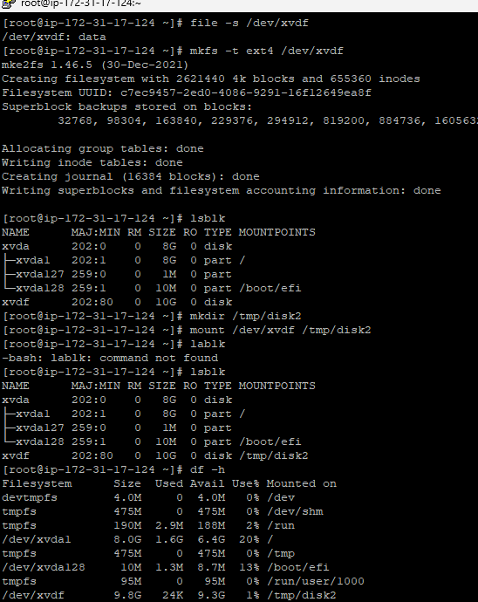

Mount volume 🡪 mount /dev/xvdf/ tmp/disk2

Successfully mounting the a new volume to the existing instance.